A Project Report On

**Café Management System**

Submitted in partial fulfillment of the requirement for the award of the degree

Bachelor of Computer Application

BCA

Academic Year 2025 – 26

**Kanani Jinal Bhuva Kavya Sojitra Devanshi**

**92300527036 92300527006 92300527005**

|  |
| --- |
| **Internal Guide** |
| (Name of Internal Guide) |



Rajkot-Morbi Road, At & PO : Gauridad, Rajkot 360 003. Gujarat. India.



**Faculty of Computer Applications (FCA)**



**This is to certify that the project work entitled**

**Café Management System**

**submitted in partial fulfillment of the requirement for**

**the award of the degree of**

**Bachelor of Computer Application**

BCA

**of the**

**Marwadi University**

**is a result of the bonafide work carried out by**

**Kanani Jinal (92300527036)**

**Bhuva Kavya (92300527006)**

**Sojitra Devanshi (92300527005)**

**during the academic year 2025-26**

|  |  |  |  |  |
| --- | --- | --- | --- | --- |
| **Faculty Guide** |  | **HOD** |  | **Dean** |

**DECLARATION**

Wehereby declare that this project work entitled **Café Management System** is a record done by me.

I also declare that the matter embodied in this project is genuine work done by me and has not been submitted whether to this University or to any other University / Institute for the fulfillment of the requirement of any course of study.

Place : Marwadi University

Date : 09/06/2025

**Kanani Jinal (92300527036) Signature : jinal**

**Bhuva Kavya (92300527006) Signature : kavya**

**Sojitra Devanshi (92300527005) Signature : devanshi**

**CONTENTS**

|  |  |  |
| --- | --- | --- |
| **Chapters** | **Particulars** | **Page No.** |
| **1** | **SYNOPSIS** |  |
| **2** | **PREAMBLE**  General Introduction  Module description |  |
| **3** | **TECHNICAL DESCRIPTION**  Hardware Requirement  Software Requirement |  |
| **4** | **SYSTEM DESIGN AND DEVELOPMENT**  **(Only applicable diagrams)**   * Flowchart * Diagram |  |
| **5** | **CONCLUSION** |  |
| **6** | **LEARNING DURING SIP** |  |
| **7** | **BIBLIOGRAPHY**  Online References  Offline References |  |

**SYNOPSIS:**

**1. Introduction:**

In the fast-paced food and beverage industry, efficient management of orders, billing, and inventory is critical to customer satisfaction and profitability. The **Café Management System (CMS)** is a web-based application designed to streamline café operations such as order management, billing, menu updates, and staff coordination. This digital system minimizes manual errors, reduces wait times, and enhances the overall customer experience. With a user-friendly interface and backend automation, the CMS provides a centralized platform to manage all core functions of a café.

### ****2. Objectives of the Project:****

* To develop a simple, fast, and secure café management system.
* To manage café orders, billing, and inventory digitally.
* To streamline staff and table management.
* To enhance customer service through faster processing and data accuracy.
* To reduce dependency on manual operations and paper-based billing.

### ****3. Methodology / Development Approach:****

* **Backend Language:** Python

**General Introduction:**

➤ In today’s fast-paced digital era, small businesses like cafés require efficient tools to manage their daily operations. A **Café Management System** is a software application designed to streamline order processing, billing, and inventory handling within a café environment. This system reduces manual work, minimizes errors, and enhances customer service by digitizing the entire workflow. By using Python and GUI technologies, this project provides a user-friendly interface for managing menu items, recording orders, and generating bills quickly and accurately.

**Module Description:**

### 1. User Interface Module:

### Built using Tkinter, this module creates a full-screen graphical user interface.

### Displays the café menu, allows item selection, and lets users choose quantity through dropdown menus.

### Shows order summary and provides buttons for adding items, calculating total, and clearing orders.

### ****2.**** Menu Management Module:

### Stores the menu items and their prices in a dictionary.

### Displays the menu dynamically on the GUI.

### Supports easy updates to menu items and prices.

### ****3.**** . Order Processing Module:

### Handles adding selected items and quantities to the current order.

### Updates the order summary with item-wise costs.

### Calculates the total bill including tax and service charges.

### ****4**** Billing Module:

### Calculates subtotal, applies tax (5%) and service charge (10%), and shows the final amount.

### Provides an interactive popup for bill details

### ****5.**** Utility Module:

### Includes error handling and validation for menu selections and quantity inputs.

### Supports clearing the current order for new transactions.

### Allows exit from the fullscreen interface using the Escape key.

**Hardware Requirement:**

**Minimum Hardware Requirements :**

| * **Processor:** Intel Core i3 or equivalent (minimum) |
| --- |
| * **RAM:** 4 GB or higher |
| * **Storage:** At least 500 MB free disk space for application files and data |
| * **Display:** Monitor with minimum resolution 1024x768 for proper GUI display |
| * **Input Devices:** Keyboard and Mouse (for interacting with the system) |
| * **Operating System:** Windows, macOS, or Linux capable of running Python and Tkinter |
| * **Optional:** Printer (for printing bills and receipts) |

**Software Requirement:**

**Operating System:**

* **Windows 7 or later / macOS / Linux**

**Programming Language:**

* **Python 3.x**

**GUI Library:**

* **Tkinter (built-in with Python)**

**Image Processing:**

* **Pillow (PIL) library for handling images**

**IDE/Text Editor:**

* **Any Python-compatible IDE (e.g., PyCharm, VS Code) or simple text editor**

**Additional Software:**

* **Python must be installed on the system.**
* **Required Python packages (e.g., Pillow) can be installed via pip**

**SYSTEM DESIGN AND DEVELOPMENT :**

Flowchart:

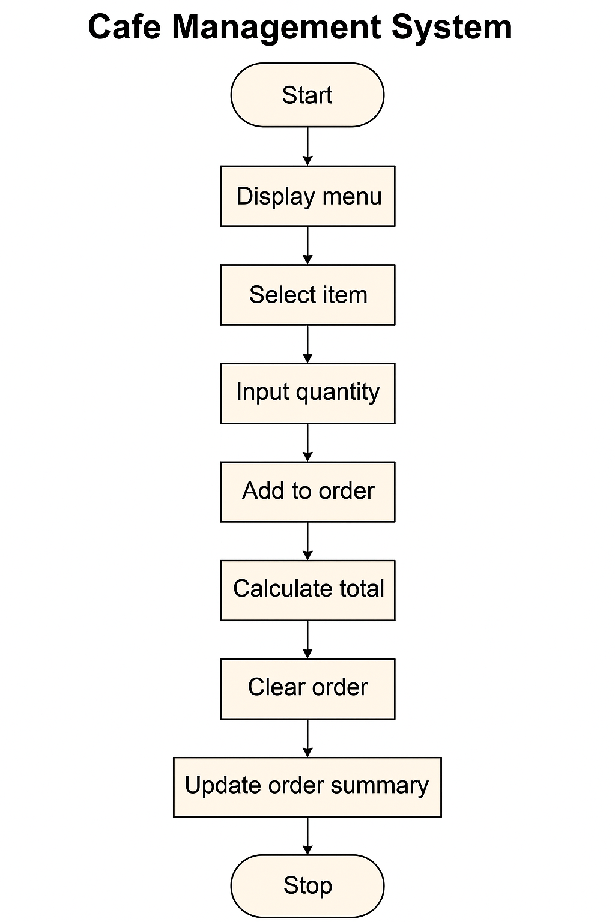

Diagram:

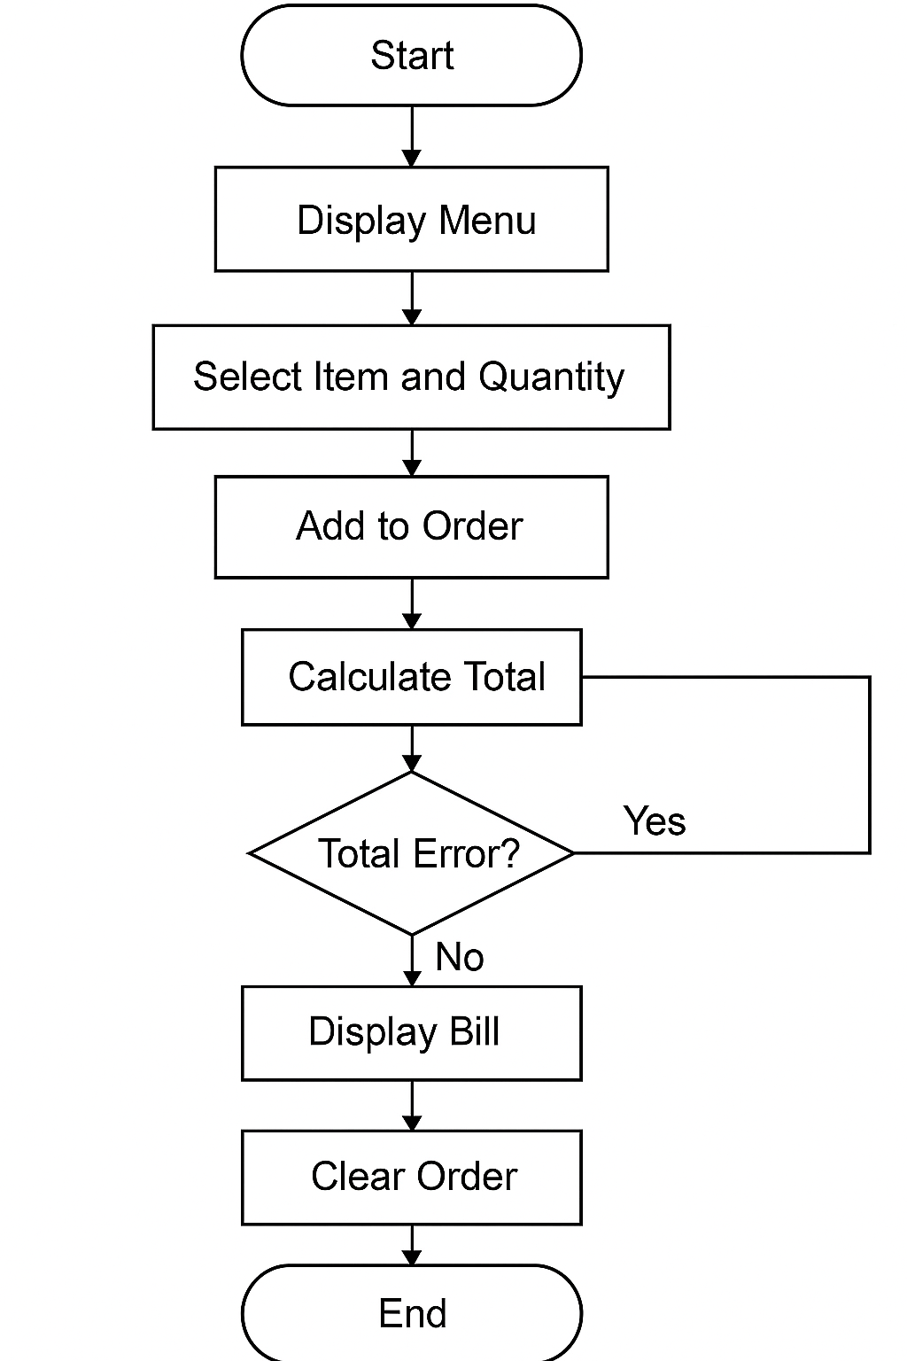

**What platform are you targeting?**

* Desktop (Python with Tkinter GUI)

**Which screens do you need designed and coded?**  
For example:

* **Add Menu Item** (to add new food or drink items to the menu)
* **Place Order** (main screen to select items and quantity, add to order)
* **View Order Summary** (shows current order details before checkout)
* **Calculate Bill** (displays total amount with taxes and service charges)
* **Clear Order** (option to reset the current order)

Optional screens for extended functionality:

* **Manage Inventory** (track stock of ingredients/items)
* **View Sales Reports** (daily or monthly sales summary)
* **User Login** (for staff access control)
* **Settings** (change tax rates, service charges, or UI themes)

**CONCLUSION:**

* The Cafe Management System developed using Python and Tkinter provides an efficient and user-friendly desktop application for managing cafe orders. It allows easy selection of menu items, quantity input, order summary display, and automatic calculation of the final bill including taxes and service charges. The system enhances order accuracy and speeds up billing, making cafe operations smoother. With potential for further enhancements like inventory management and sales reporting, this system serves as a solid foundation for small to medium-sized cafe businesses seeking a simple yet effective digital solution.

**LEARNING DURING SIP :**

During my Summer Internship Project, I gained valuable practical experience in software development by designing and implementing a Cafe Management System using Python and Tkinter. I enhanced my understanding of GUI programming, event-driven development, and user interface design principles.

I learned how to:

* Structure a desktop application with clear modular code
* Handle user inputs and validations effectively
* Work with images and layouts to improve user experience
* Implement core features such as order management, billing calculations, and dynamic updates
* Debug and troubleshoot errors in real-time applications

Additionally, the project improved my problem-solving skills and gave me insights into real-world requirements for restaurant management software. It also helped me appreciate the importance of clean UI/UX design and responsiveness for end-users.

Overall, the SIP was a great learning platform that bridged my theoretical knowledge with practical application, preparing me for future software development challenges.